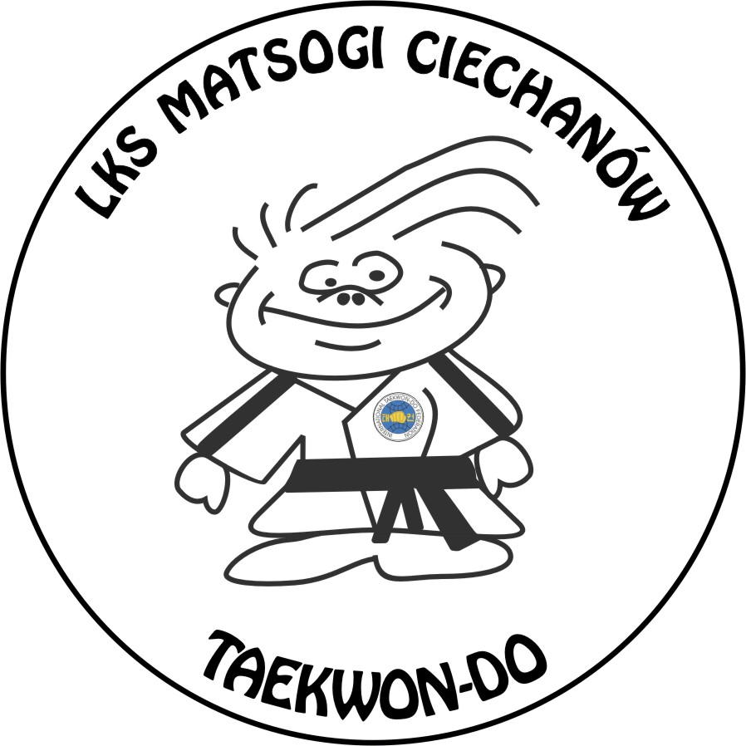
Ludowy Klub Sportowy MATSOGI CIECHANÓW
06-400 Ciechanów ul. Warszawska 28
Tel. kom +48 607 133 234, e-mail: mkorzybski@wp.pl, www.matsogi.pl
Konto: Bank Spółdzielczy w Ciechanowie 84821300082001000487120001

„MASTERS MAZOVIA CUP 2008”

The organizers of „Masters Mazovia Cup 2008” have honor to invite following competitors to participate in the Taekwon-do Tournament to be held from 7th to 8th November 2008 in Ciechanow (Poland).

Female sparring up to 63 kg:
- Joanna Paprocka, Poland
- Cecilia Akesdotter, Sweden

Male sparring up to 63 kg:
- Redzo Ljutic, Slovenia,
- Robert Schell, Germany

Male sparring up to 71 kg:
- Piotr Wasilewski, Poland
- Ernest Neil, Wales

Male sparring up to 80 kg:
- Daniel Działa, Poland
- Alexander Aronsen, Norway

The cost of participation of the invited competitors and their coaches will be covered by the organizers (accommodation – two hotel days – from 7th to 9th November 2008 and entry fee).
The organizer doesn’t cover the cost of transport. Only for invited competitors from abroad the organizer can arrange and cover the costs of transport from Warsaw Airport to Ciechanów and back after (prior the determination of travel exact schedule).

Other competitors willing to participate in the tournament will cover the costs of participation at the tournament at theirs own expenses.

The organizer funded cash prices for winners in the sparring categories:
I m-ce – 500 Euro,
II m-ce – 250 Euro,
III m-ce – 100 Euro (two third places)

All invited competitors will start rivalry from the semifinals. Both will be put to the different parts of the pyramid system.
The organizers kindly ask the invited competitors to confirm their participation in MMC 2008 on 30th September, 2008 on the email mkorzybski@wp.pl

Lack of confirmation on the deadline will be treated as rejection of the invitation.

We are looking forward to meeting you in Ciechanow (Poland)!

Michał Korzybski
Chairman
Of the Organizing Committee

